**PROJECT REPORT**

on

**FACIAL RECOGNITION ATTENDANCE SYSTEM**

(CSE V Semester)

2021-22



**Submitted To : Submitted By :**

Ms. Manika Manwal Priyanshu Padeliya

(CC-CSE-I-V-Sem) Roll No : 1918568

CSE-I-V-Sem

Session : 2021-22

**DEPARTMENT OF COMPUTER SCIENCE AND INFORMATION TECHNOLOGY**

**GRAPHIC ERA HILL UNIVERSITY,DEHRADUN**

**ABSTRACT**

Face recognition is one of the most demanding applications and has an important role in the technical field. Recognition of the human face is an active issue for authentication purposes specifically for the attendance of students.

Attendance system using face recognition is a procedure of recognizing students by using face biostatistics based on monitoring and other algorithms. The development of this system will digitalize the traditional system of taking attendance by calling names and maintaining pen-paper records. Present strategies for taking attendance are tedious and time-consuming. Attendance records can be easily manipulated by manual recording. The traditional process of making attendance and present biometric systems are vulnerable to proxies.

This program tries to solve these problems. The proposed system makes the use of CNN, Histogram of Oriented Gradients,face landmark estimation.

After face recognition , attendance reports are generated and stored in excel format. The system is tested under various conditions like illumination, head movements, the distance between the student and camera.

After testing , overall complexity and accuracy are calculated. This system proves to be an efficient and robust device for taking attendance in a classroom without any time consumption and manual work.

**INTRODUCTION AND MOTIVATION**

A facial recognition attendance system uses facial recognition technology to identify and verify a person using the person’s facial features and automatically mark attendance.

A facial recognition attendance system is a contactless way to manage visitors , employees , students in an organisation.

It’s not like other biometric systems, such as fingerprint that captures identity through touch , a facial recognition system is a contactless way to manage employees and visitors.

The software can be used for different groups of people such as employees , students, etc. The system records and stores the data in real time.

COVID-19 pandemic resulted in spread of virus from physical contact. So during lockdown duration it was online world only where everyone spent their time.

Being a student I have to join online classes and during our class teacher used to call us by names for taking attendance or by taking the report of students who have joined the meeting/class. During this time only I thought of taking attendance via camera of devices and attendance will be taken without disturbing the class so teacher don’t have to do extra work and increase their work load.

Mobile phone’s face unlock also motivated to do this project , as a 2D picture won’t be accepted by it and only a 3D figure would do the work. Shadows also play an important role, movement of head and distance of face from camera all these constraints together followed make it possible to authenticate the face recognition process, and face id is matched with the one stored in data memory.

Face recognition works the same way in every device. It takes picture of you , recognise face ,binds rectangle , matches face with every face present in database of trained model and recognises you, then mark the attendance.

**METHODOLOGY USED**

**128** measurements are extracted from a human face to identify him.

* **HOG(Histogram of Oriented Gradients) to find faces**
* Make image b/w and mark gradients(lines showing flow of pixels from light to dark)
* Take a part of image and match it with trained images HOG that was extracted from a bunch of other training faces.
* **Projecting faces**

**-**faces turned different look totally different to a computer.

**ALGORITHM USED -**> **FACE LANDMARK ESTIMATION**

68 specific points (landmarks) exist on every face.

* Train a algorithm to be able to find these 68 measurements for each face.
* **EMBEDDING**
* Train a Deep Convolution Neural Network (CNN) to generate 128 measurements of each face.
* **Finding a person’s name from the encoding**

-use any ML classification algorithm to find a person name from the database who has the closest measurements to our test image.

* An images folder is created in a database where data model is trained and saved.
* For every individual children or person you have to create a subfolder with the name or roll no. of that student/person.
* mylist tells the population of images folder i.e. no of students.
* Camera takes photo in **BGR** and uploads the same , for processing and displaying you have to convert it to **RGB** using the function cvtColor().
* encoding of image is done i.e. all important features required to identify a face are obtained from a image for comparison.
* **ENCODING**

important measurements on the face - like the color and size and slant of eyes, the gap between eyebrows, etc.

All these put together define the face encoding — the information obtained out of the image — that is used to identify the particular face.

* Video is captured then using live camera of laptop :

cap = cv2.VideoCapture(0)

* here (0) shows that internal camera is used i.e. built-in camera
* (1) would mean that an external camera is being used to capture video.
* Images captured are further processed for gradient
* Gradient is matched for already processed images
* If gradients of our picture matches with trained gradients then it’s a match and image is identified
* Image’s name whatever it is (file name by which it is saved) is entered in excel sheet along with time and date of attendance.
* Excel sheet is generated as attendance report.

**LIBRARIES USED**

* **opencv**

(import cv2)

- used for face detection

- opencv with it’s inbuilt deep neural network (dnn) face detector uses SINGLE SHOT DETECTOR (SSD) framework

- creates a dataset of face images

- Extract face embeddings for each face in the image (again, using OpenCV)

-Train a model on top of the face embeddings

-Utilize OpenCV to recognize faces in images and video streams

* **numpy**

(import numpy as np)

* numpy is the fundamental package for scientific computing in python which provides a multidimensional array object.
* Other mathematical operations can be performed using this.
* We only need it to convert our images into some form of an array so that we can store the model that has been trained
* **face_recognition**

(import face_recognition)

* it’s a python based library that has predefined trained networks to perform facial measurement calculations.
* face recognition trained CNN to generate 128 measurements of any face , and published several trained networks.
* Run any face image through their pretrained network to get 128 measurements.
* **Datetime**

(import datetime)

* Used for entering date and time of attendance entered in excel sheet.
* When a picture is taken from webcam of a laptop or any external camera, it associates date and time with every record entered in file.

**RESULT**

Facial Recognition Attendance System is working properly with multiple recognition of people in the frame.

It feeds data into the excel sheet as soon as a face is identified by our model, which is present in our training dataset or a student of a class.

Live attendance is taken along with date & time for validation .

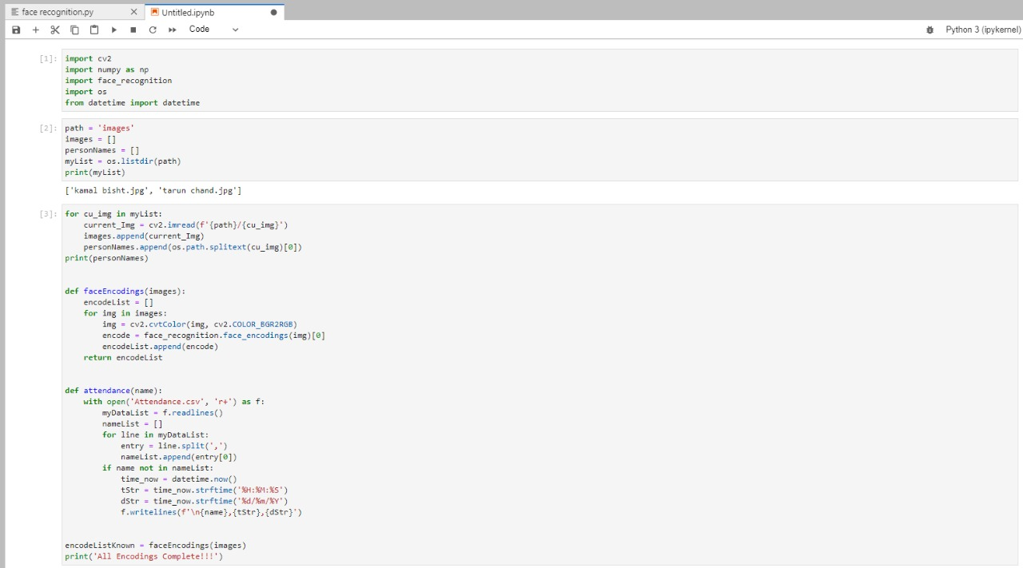

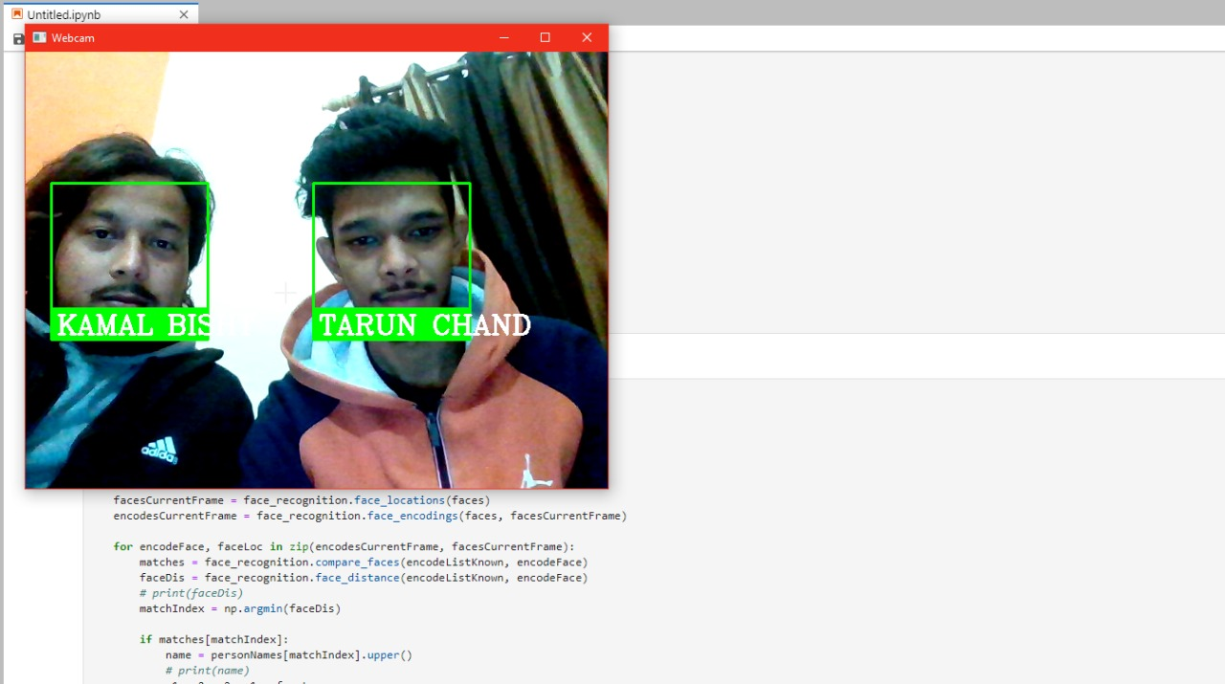

**REFERENCES**

1. https://pythonhosted.org/face_recognition/readme.html
2. Hands on Machine Learning – Aurelien Geron